6/2023



salah tawafsha

1200339

investigation using FTK-Imager and Active Disk Editor

Instructor: Dr. Mohammad Alkhanafseh

Contents

First Requirement: build an image for Disk drive 3

Second Set of Requirements: 7

• divide the HDD into 8 different partitions 7

• File System of Each partition 12

• Type of each partition 15

• Find size and start sector of each partition. 16

• Partitions signatures 19

• delete two partitions and list information about deleted partitions. 20

Third Requirement (FTK Imager) 23

• Open Image 23

• Search for a specific file 25

• Define the size of file in KB 27

• Define the first sector of the selected file 28

• Define if the file was sequence stored or not 28

• define different partitions of file NOT in sequence. 28

• Select the content of the file (fragmented file). 28

• Store and recover both files 29

# First Requirement: build an image for Disk drive

1. Install FTK imager and open it.
2. Open “File” from toolbar then go to “Create Disk Image”. 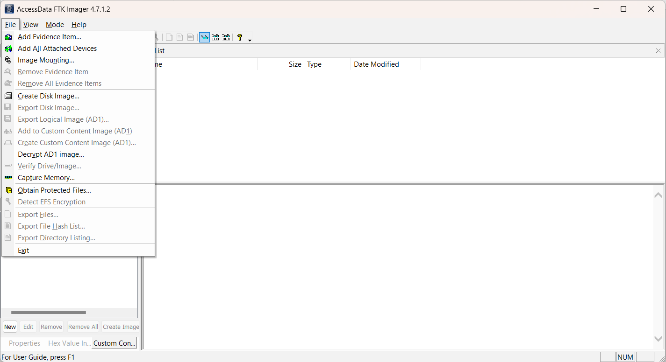
3. I will create image for VHH that I created in part 2. so, Select “Logical Device” as a Source then click “Next”.   
   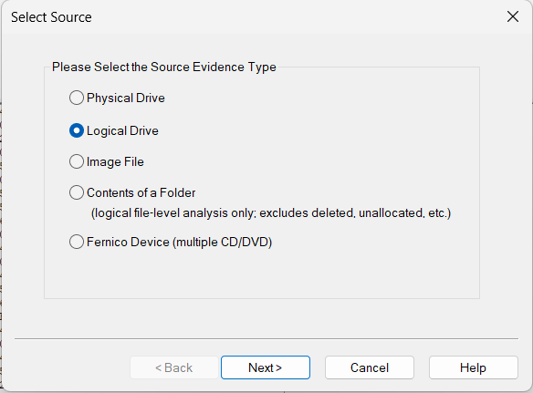

**2**

**1**

1. Select The device and click “finish”.  
   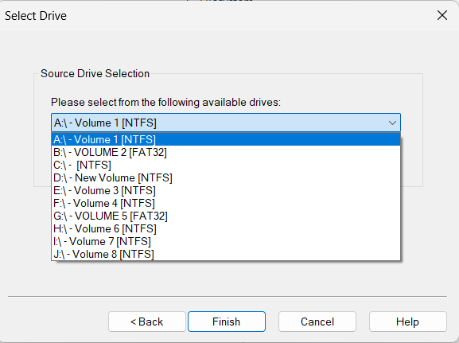

**2**

**1**

1. Now, we want to add destination that to save the image. So, click on “add”.  
   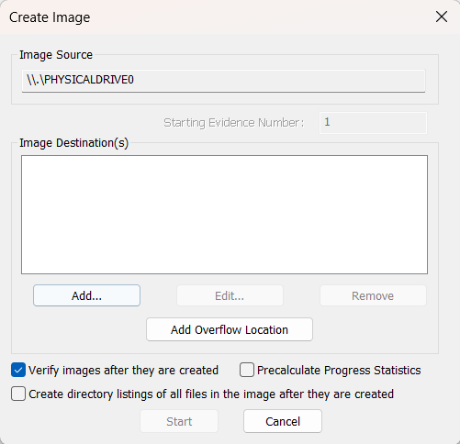
2. First, we will select the type of image file. Raw is a bit-by-bit uncompressed copy of the original, while the other three alternatives are designed for use with a specific forensics program. I will use Raw, which is an EnCase forensic image file format.   
   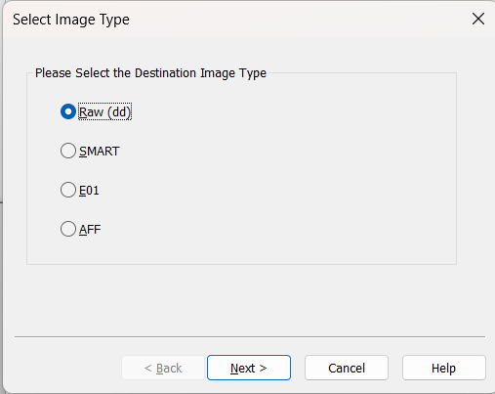

**2**

**1**

1. Then, enter key information about the evidence item and click “next”. I add this information.   
   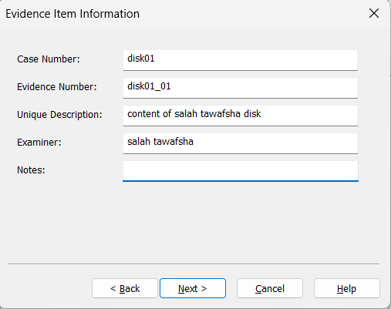
2. Now, click on browse to select folder to save image, type the filename and enter image fragment size, Image Fragment Size indicates the size of each fragment when you want to break a larger image file into multiple parts. Note that: in Raw files, compression is always 0. Finally, click “Finish”.  
     
   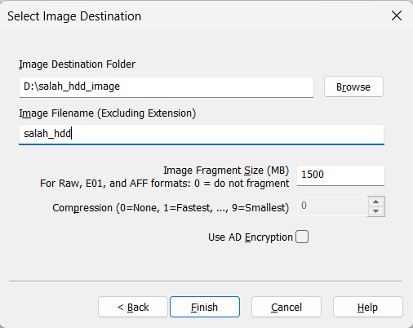
3. Finally, click on start and image will start generating. And when finished we can show summary about the image.  
   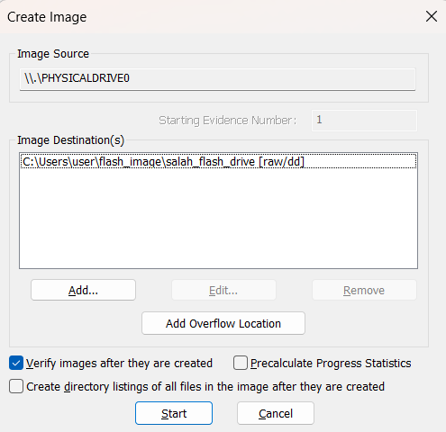

# Second Set of Requirements:

## divide the HDD into 8 different partitions

1. Press Windows key + X on your keyboard and select Disk Management.
2. Go to action -> create VHD  
   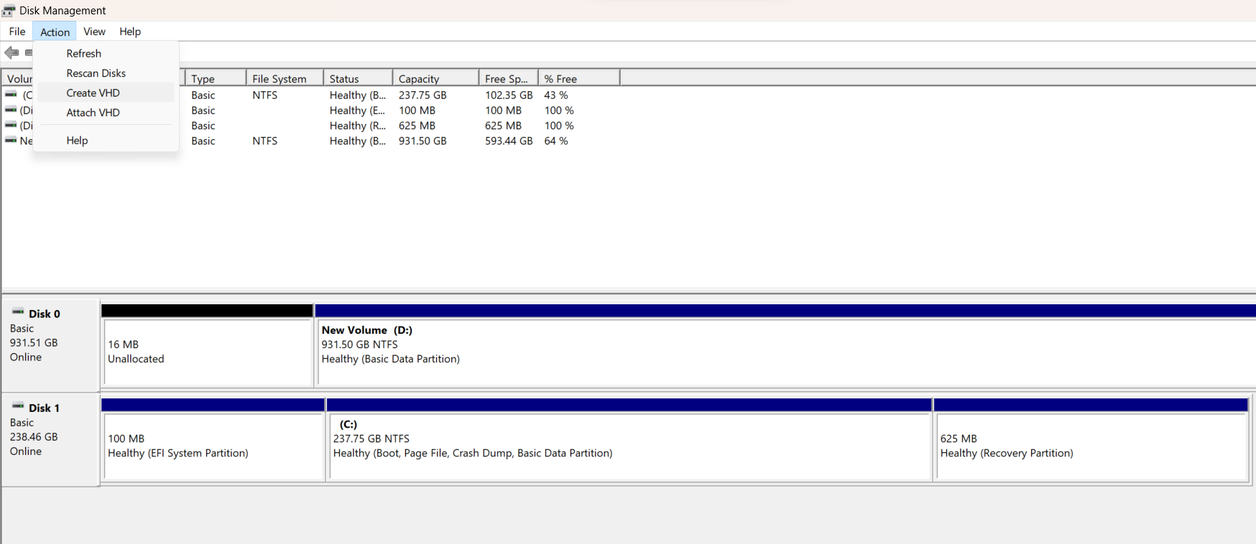
3. select location to save VHD file and size of it, then click “OK”.  
   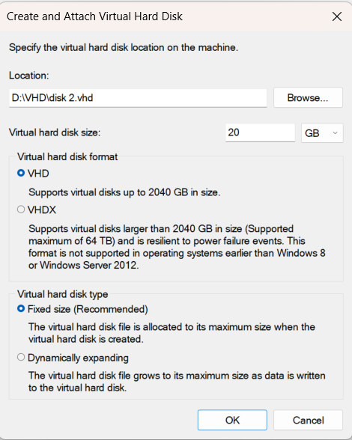
4. You will show progress bar button, wait it to finish.  
   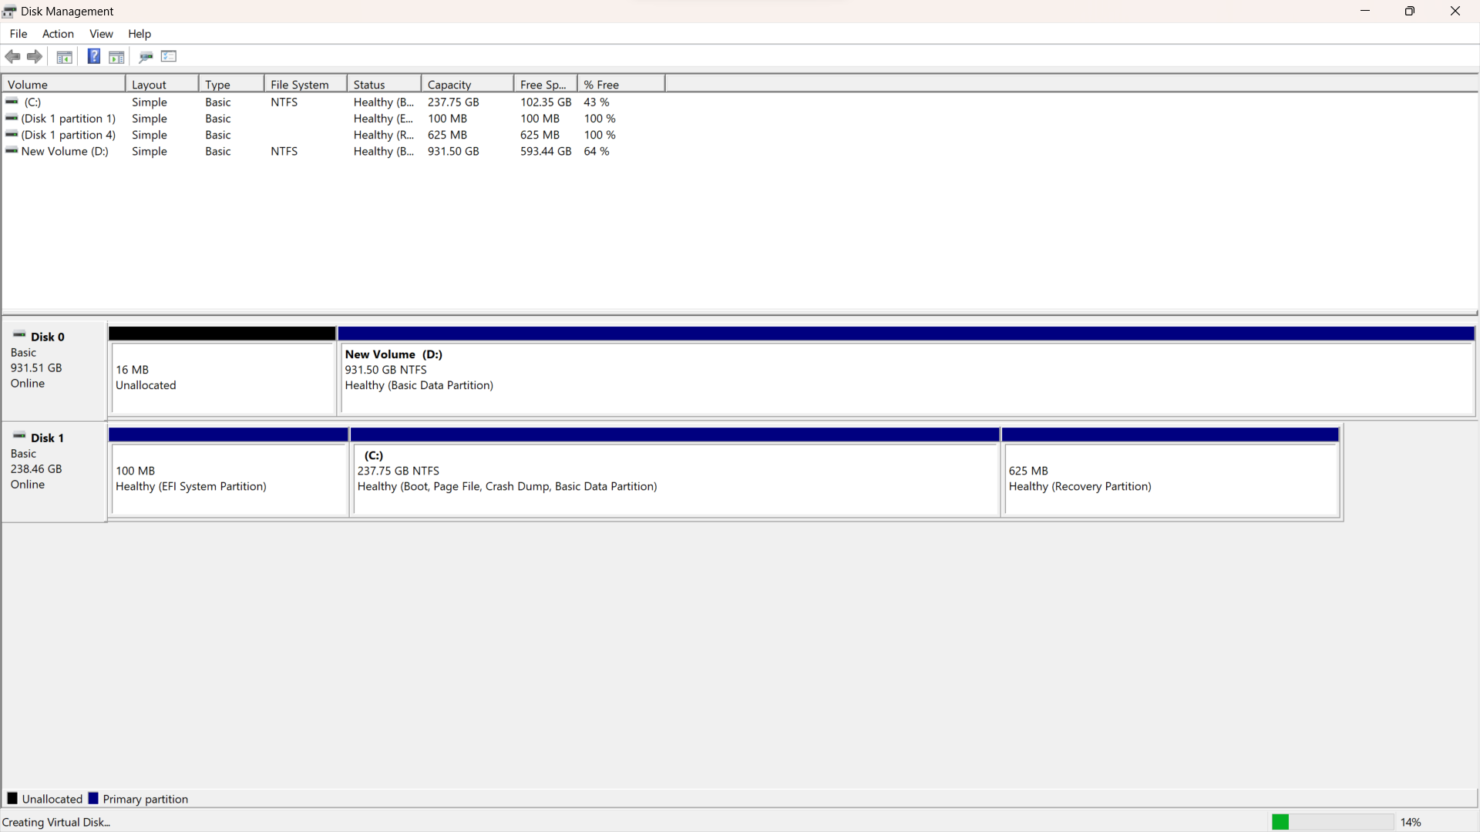
5. When it finished, you will show new hard disk. 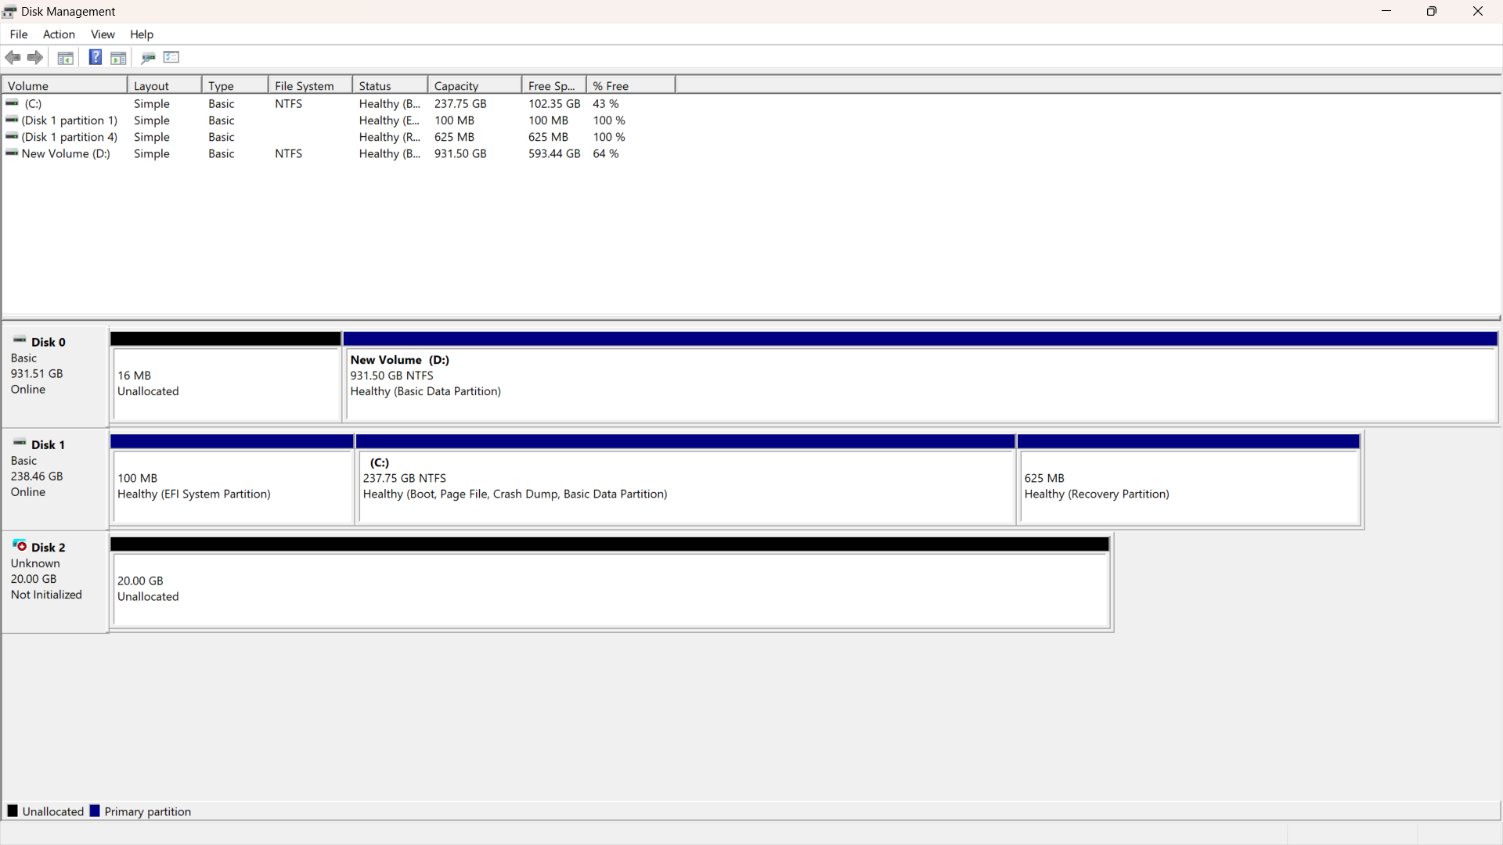
6. We must initialize it by click on it right click and select “initialize disk”.  
   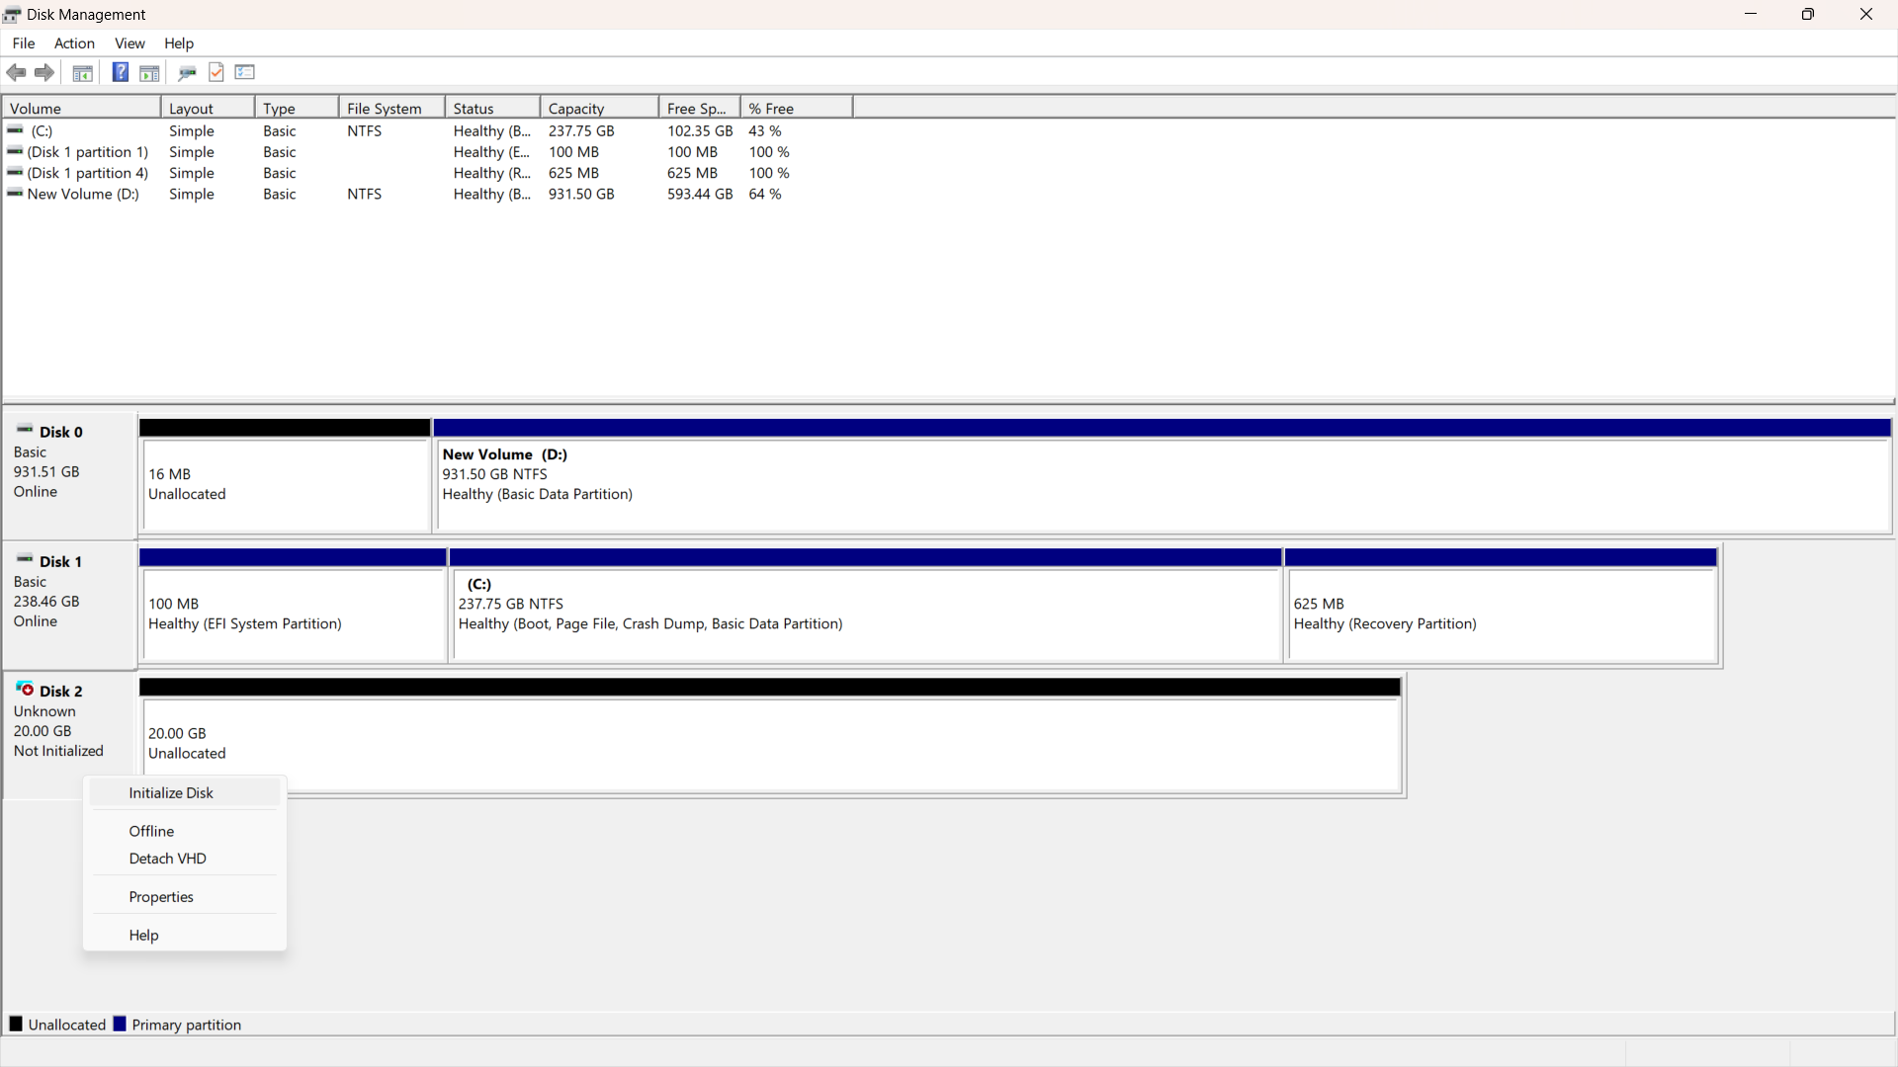
7. select MBR and click on “OK”.  
   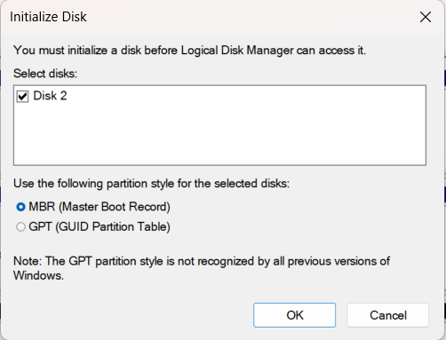
8. Now, start make partition by right click on disk and select “new simple volume”.

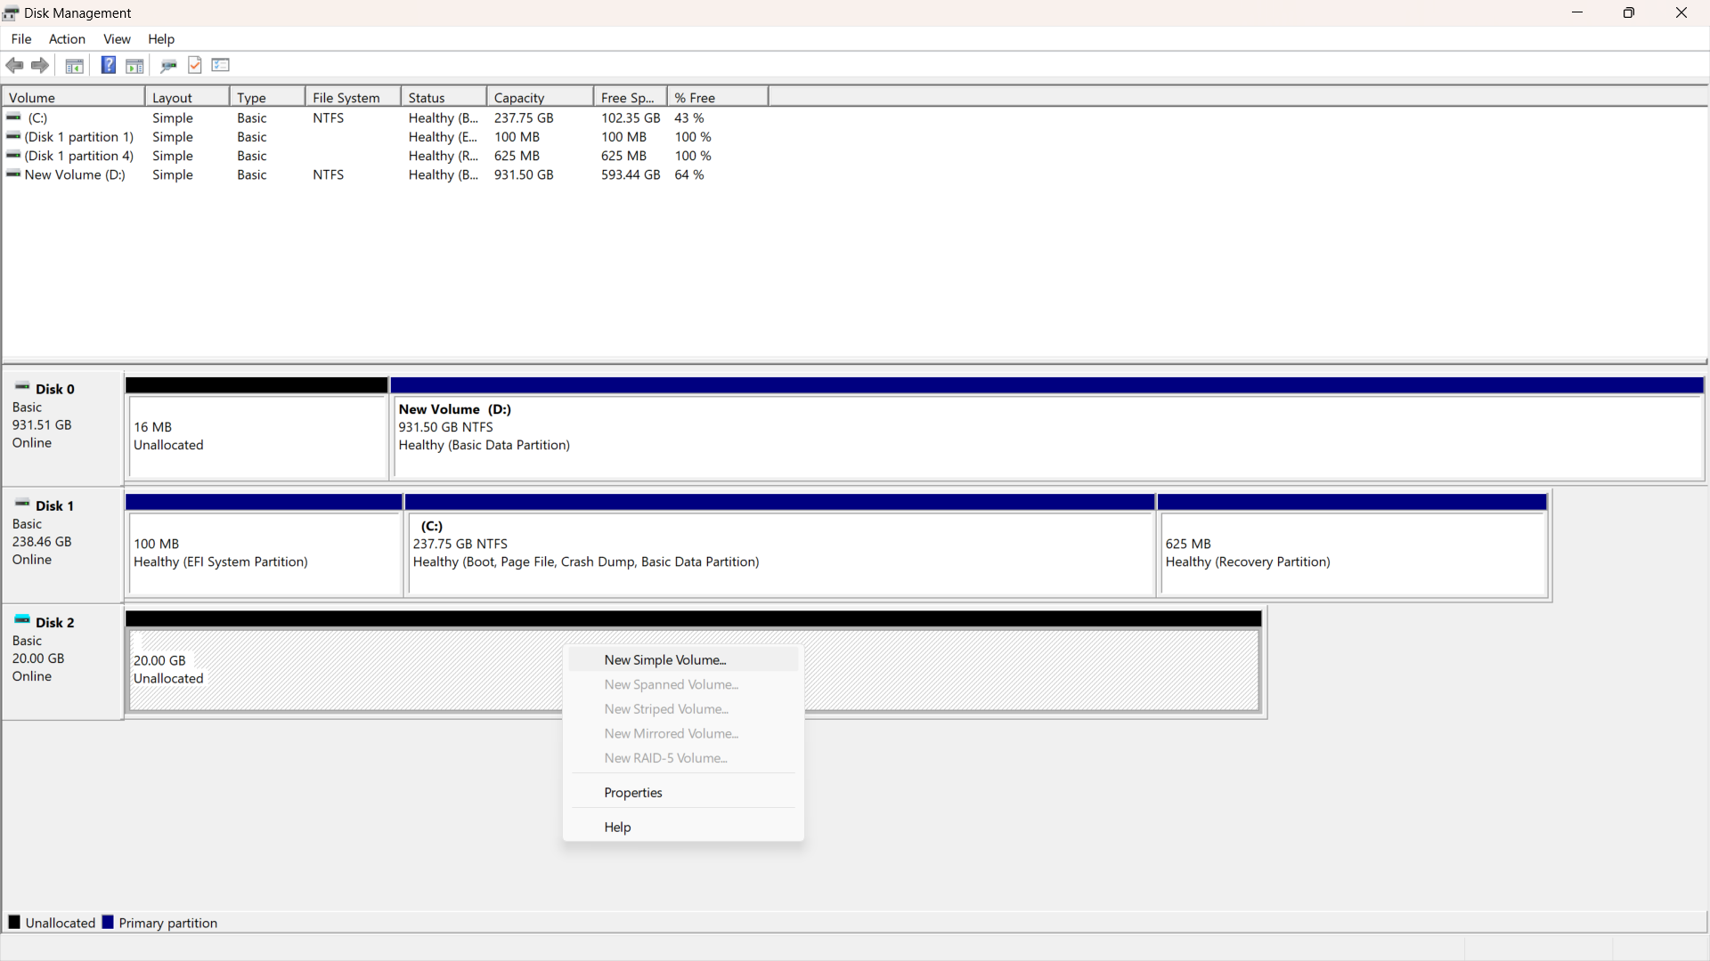

1. Select size of partition and click “next”.  
   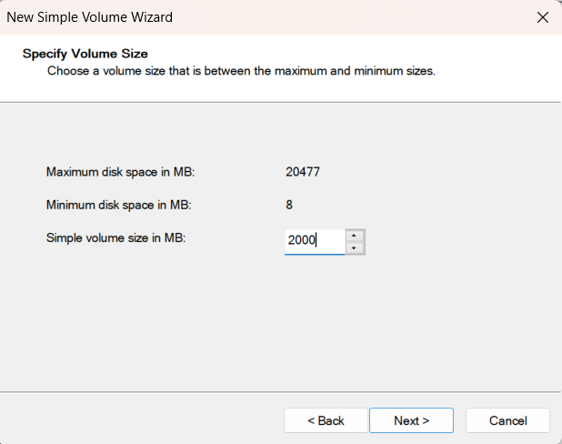
2. Now, we can assign letter to show drive as disk in “This PC” folder. Then click “Next”. 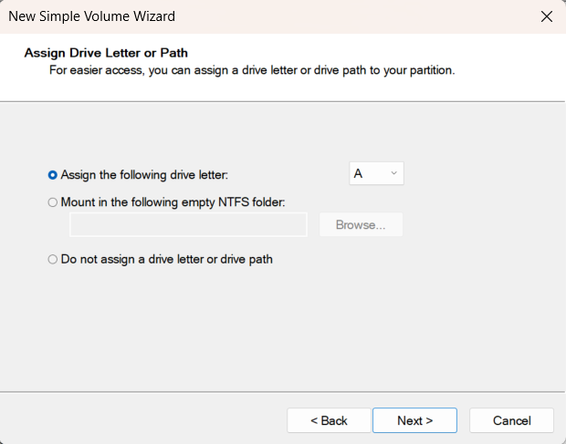
3. Now, select format of disk (file system technology, allocation unit size and volume label). Then click “Next”. You will show page have overview of disk (just click finish).  
   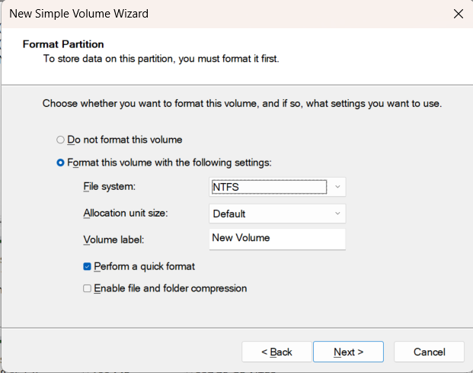

**REPEAT 1-8 for 6 times and we will find these partitions.**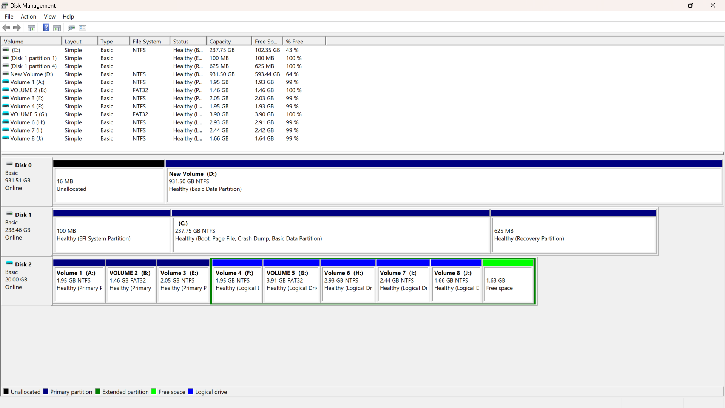

## File System of Each partition

1. Open active disk editor
2. Select the disk: From the list of available disks, choose the disk containing the partitions you want to inspect.

A. select “open desk”.  
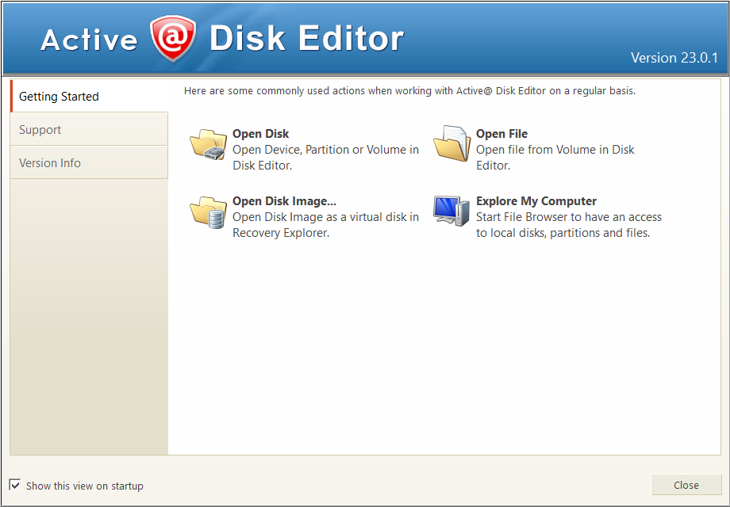  
 B. select VHD.  
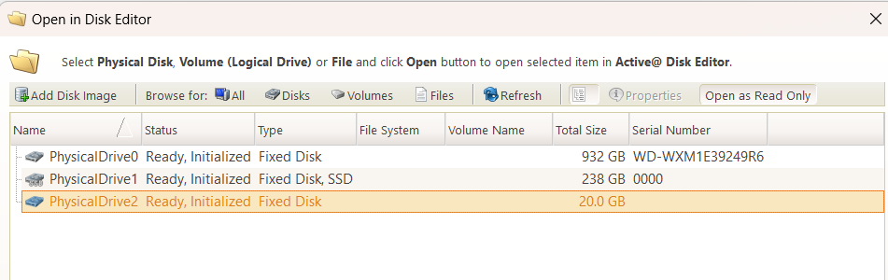

1. now, go to first sector to show File System of Each partition.  
   We must go start of partition to get type; we can do that by two ways:  
   A. look at left table and click on value of First LBA (2048), if click on 32768 go to step 3.  
   B. look at byte 8 after start of entry 1 and get 4 bytes.  
    00 08 00 00  
   it’s in little Endean, so we must reverse it as 00 00 08 00  
   this number is in Hex so to convert it will be 8 * 162 = 2048  
   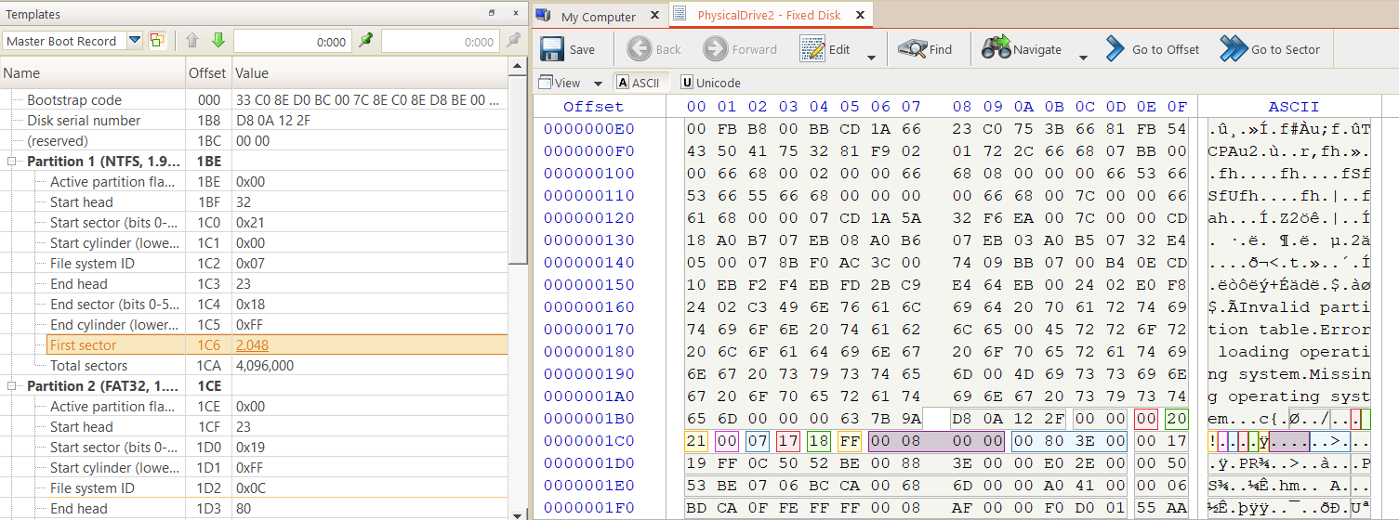
2. Go to sector 2048 by click on go to sector in toolbars.  
   
3. Enter value and click on “Go”.

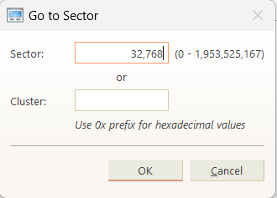

1. As it shown in Red, kind is NTFS.  
   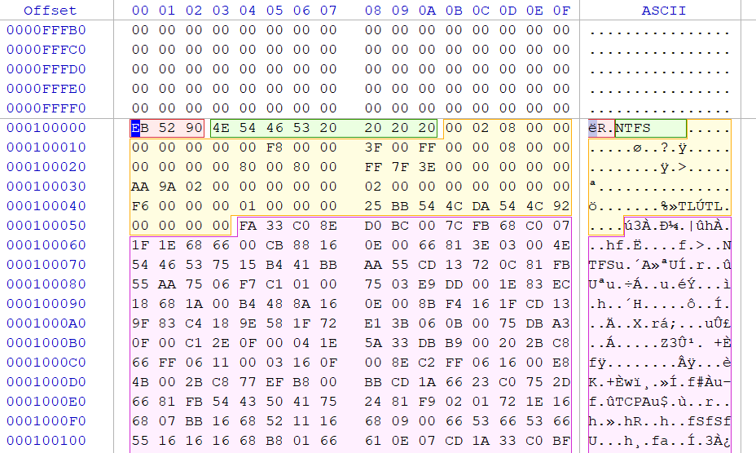
2. Note that if type is FAT32 then it will be like:

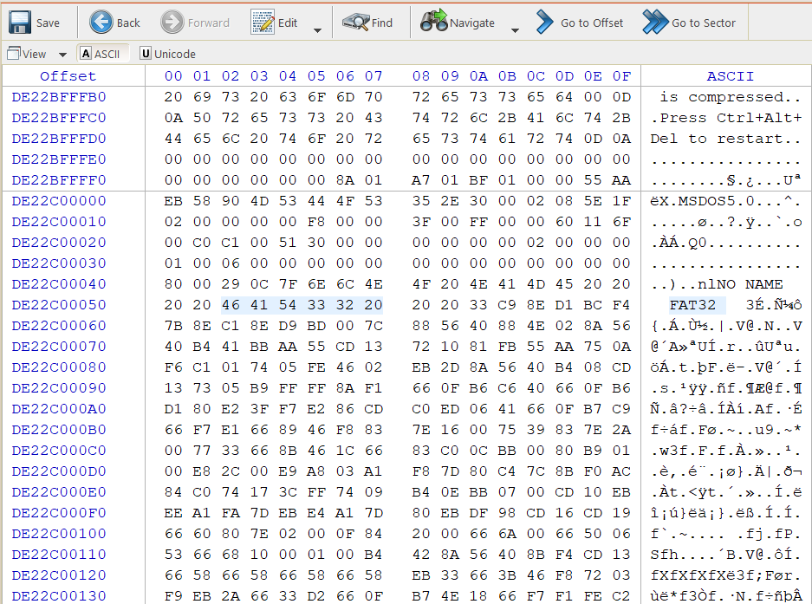

now, repeat steps 1 – 5 for 7 times.

Results:

|  |  |
| --- | --- |
| Partition# | Type |
| 1 | NTFS |
| 2 | FAT32 |
| 3 | NTFS |
| 4 | NTFS |
| 5 | FAT32 |
| 6 | NTFS |
| 7 | NTFS |
| 8 | NTFS |

## Type of each partition

Just look on File system ID, if 05 then extended else it will be primary

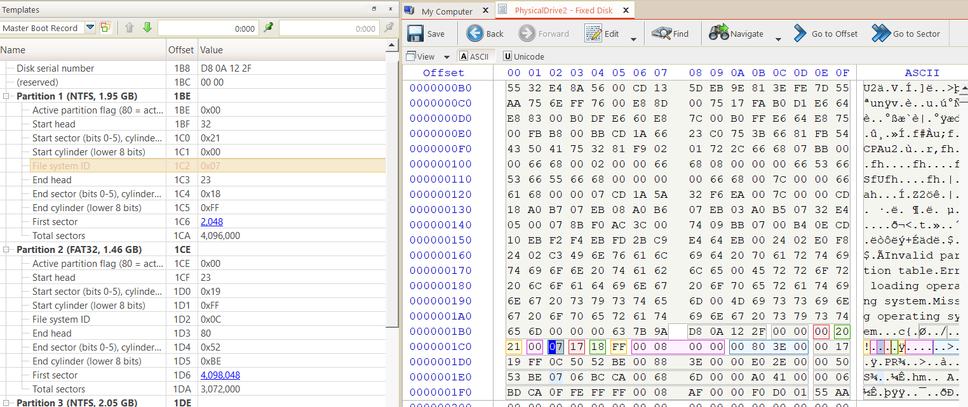

## Find size and start sector of each partition.

We can find size by two ways:

Look on Total sectors, First sector

4,096,000  
 this size in sectors => multiply by 512 => 2,097,152,000  
 this size in bytes => divide by 210 to KB => 2048,000 KB | divide by 210 to MB => 200 MB  
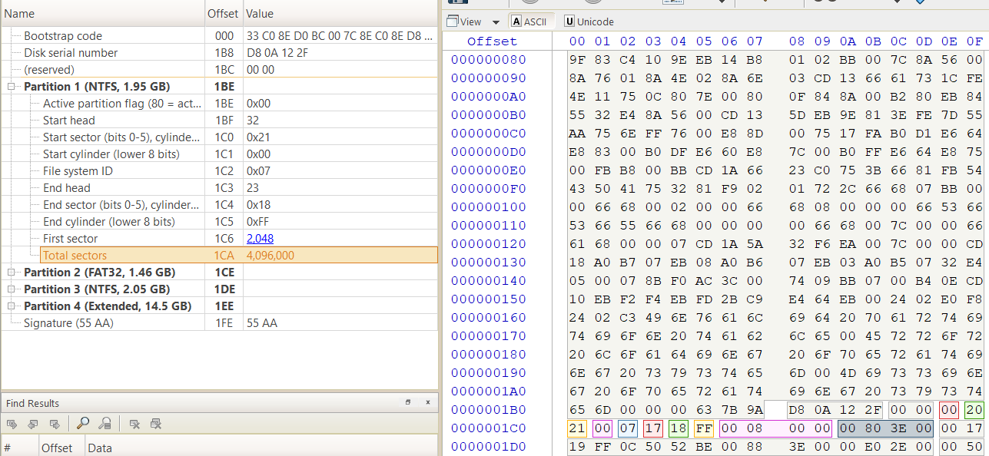  
**for partition 2, 3 it’s same as above.**

For extended partitions:

1. Get first sector (11,470,848), this is start of extended partition 1, size in next.  
   NOTE: total size that bellow this section is the size of all extended partitions.  
   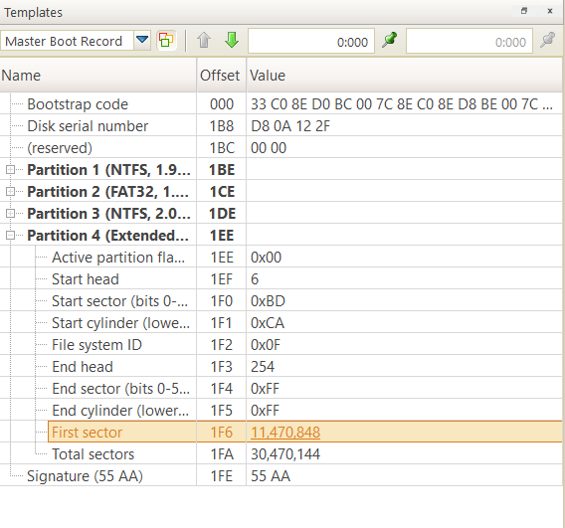
2. Go to this sector as in point 4 and 5 in File System of Each partition .  
   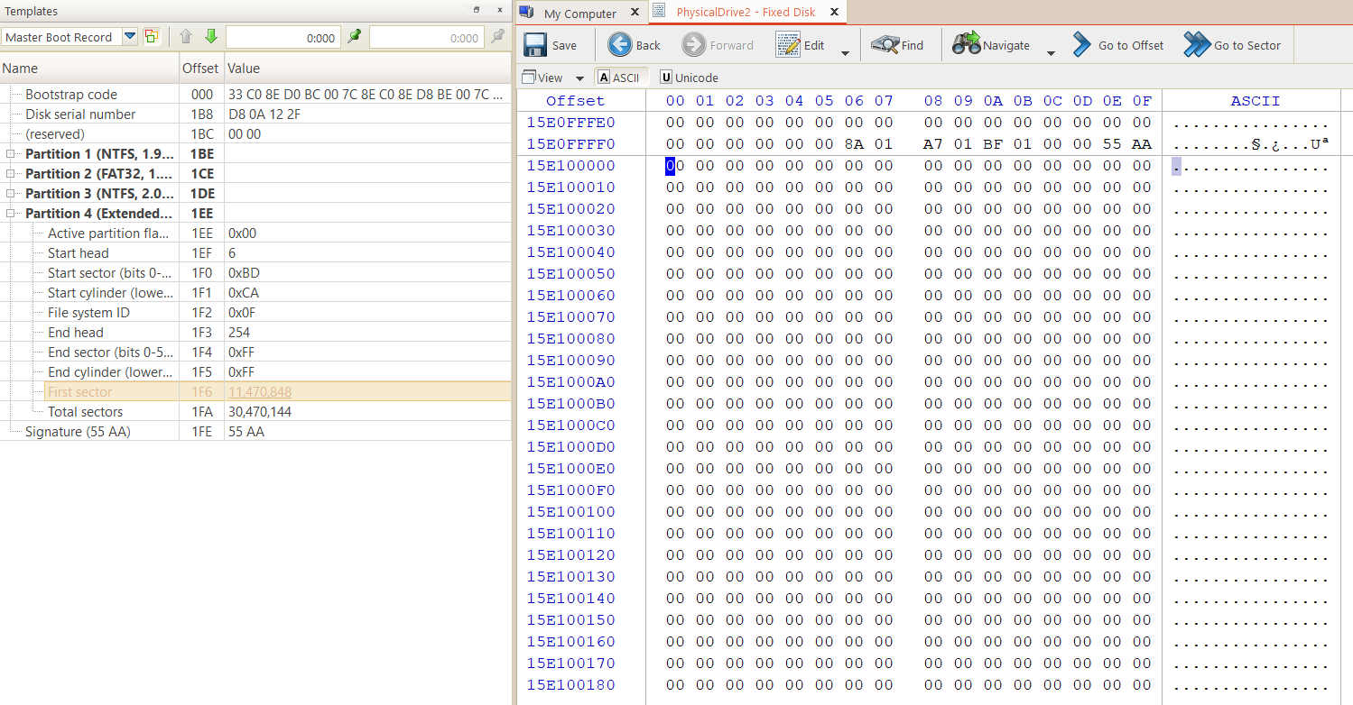
3. Then click on this button that make the template MBR refer to current position to get info easily.  
   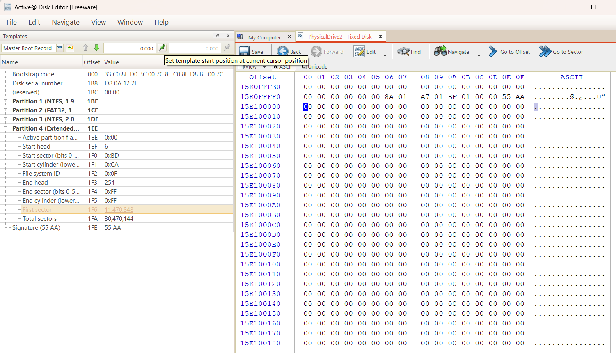
4. Now, we can find start of extended partition 2. **BUT** **we must add start sector of extended partition to this first sector (that in step A).**so 11,470,848 + 4,096,000 + 2048 = 15,568,896   
    this is starting of extended partition 2.   
   4,096,000 is the size of partition 1  
    to convert to GB => 4,098,048*512/230 = 1.95 GB

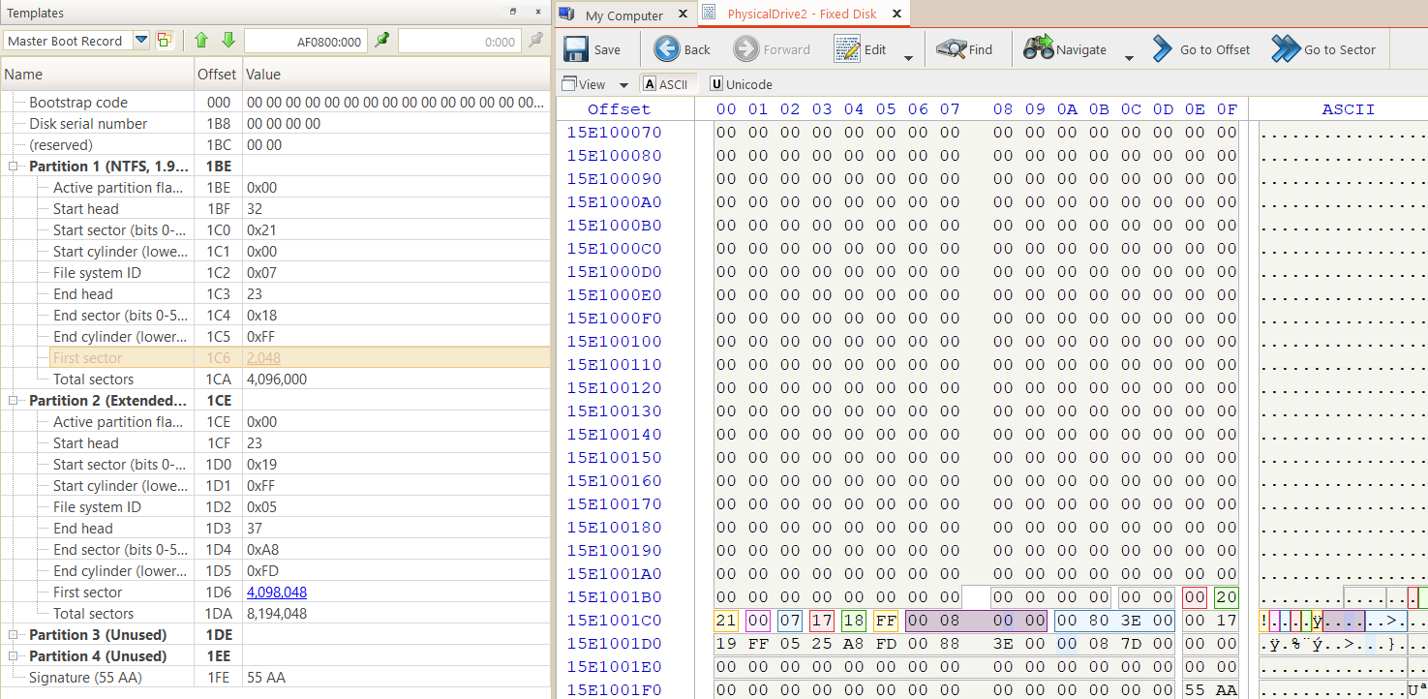

23,762,944

1. Now, go to sector 15,568,896.  
   Note that it will be same operator so:  
    15,568,896 + 2048 + 8,192,000 = 23,762,944, this is start of extended 3 … etc.  
   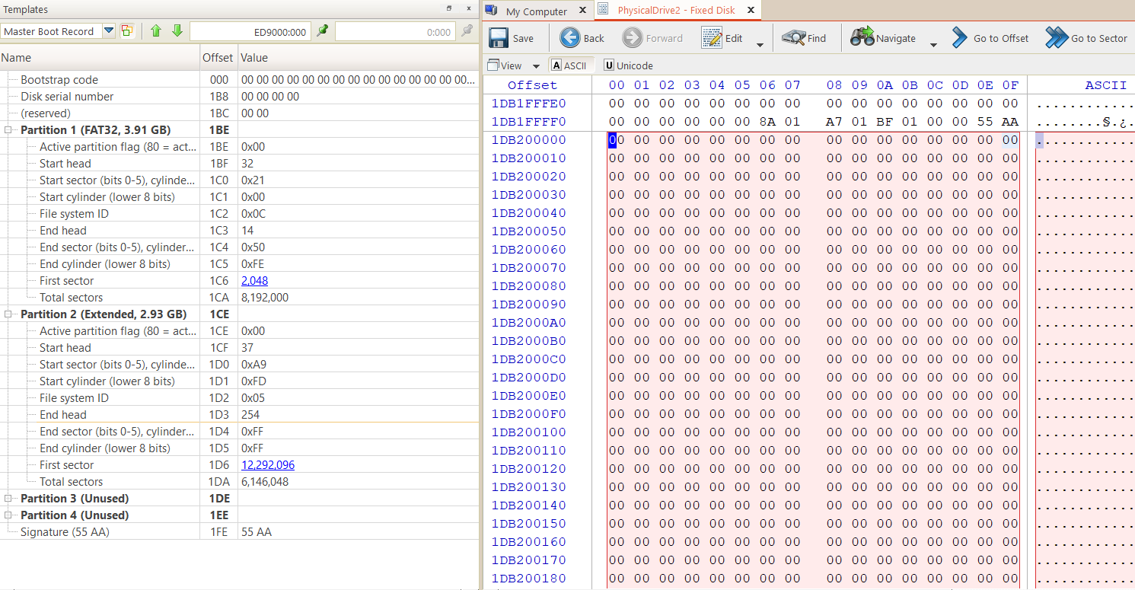
2. **RESULTS:**

|  |  |  |
| --- | --- | --- |
| Partition# | start | size |
| 1 | 2048 | 4,096,000 |
| 2 | 4,098,048 | 3,072,000 |
| 3 | 7,170,048 | 4,300,800 |
| 4 | 11,470,848 | 4,096,000 |
| 5 | 15,568,896 | 8,192,000 |
| 6 | 23,762,944 | 6,144,000 |
| 7 | 29,908,992 | 5,120,000 |
| 8 | 35,031,040 | 3,481,600 |

## Partitions signatures

all partitions will have Disk signature that will be “Disk serial number”.

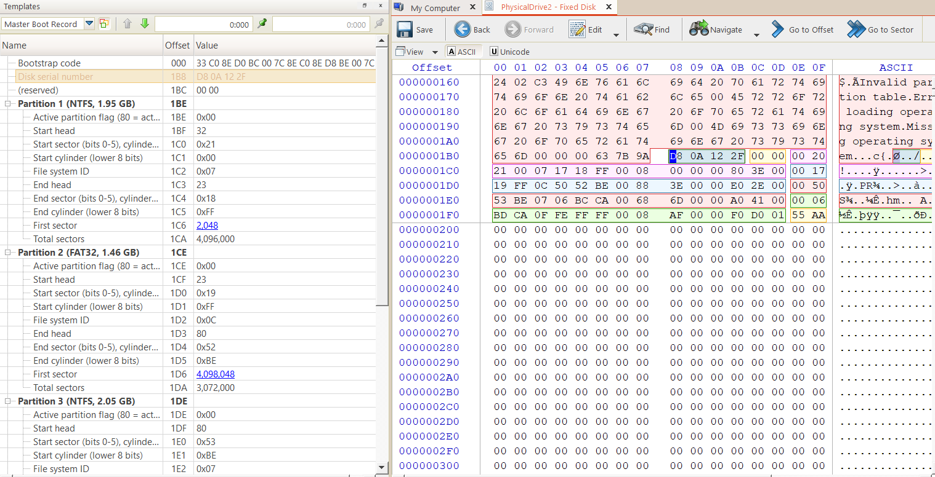

## delete two partitions and list information about deleted partitions.

1. Click window key + X.
2. Click on disk management.
3. I want to delete partition 2, Right click on partition and click “Delete Volume”  
   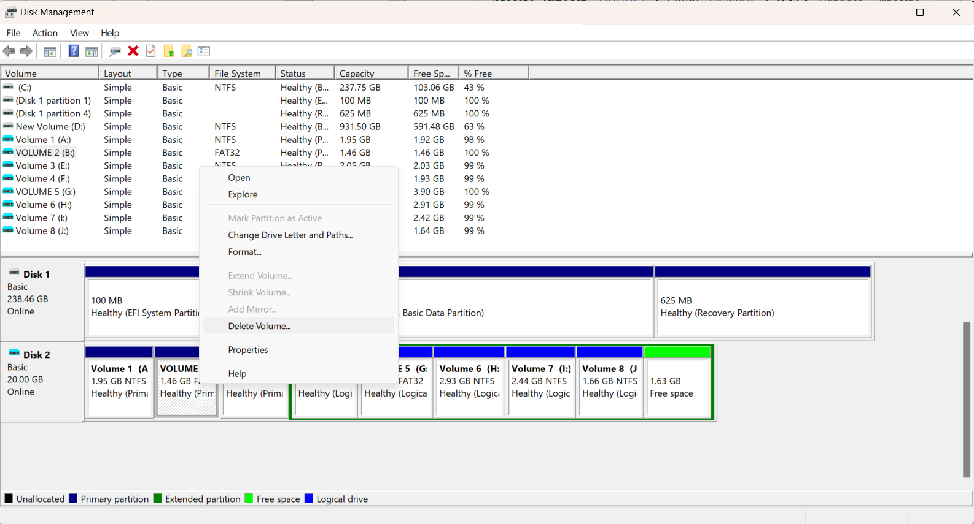
4. You will find confirm message, just click on yes.  
   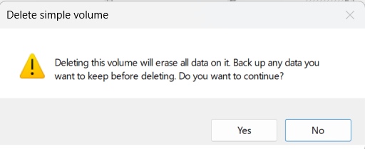

Also, I deleted Volume 2 in extended so the result is:

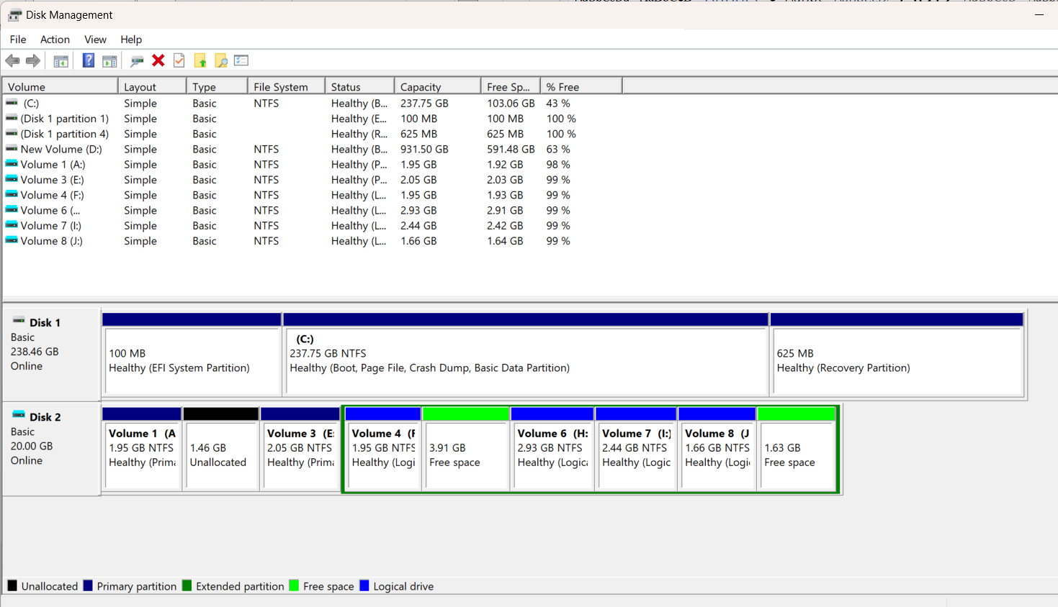  
 note that now, the partition size is shown as “Unallocated and Free space”

1. Open active disk editor.
2. When we look at templates, we note that there are fragments before partition1 and after it.

To calculate size of this deleted partitions =>   
 first sector of partition 2 - (first sector of partition 1 + total sectors of partition 1)

7,170,048 – (2,048 + 4,096,000) = 3,072,000  
 => 3,072,000*512/230 to convert to GB => 1.46 GB  
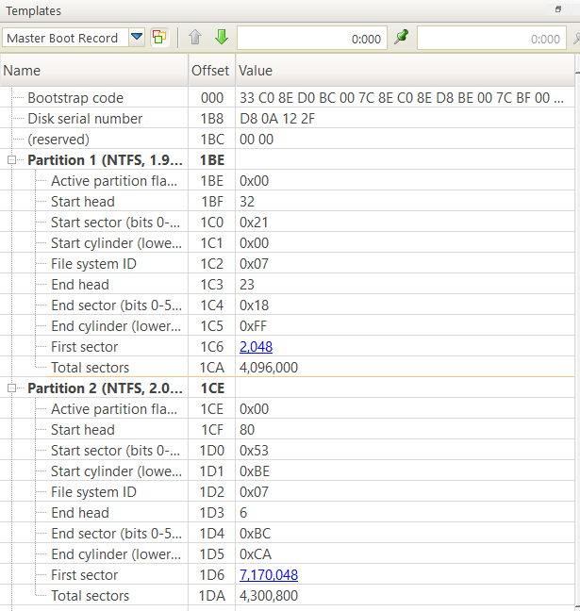

**FOR EXTENDED:**

Return to Find size and start sector of each partition. And go to extended partition and make A – C steps  
we know that this value is related to start of first sector in extended partition.  
but in this case we can ignore this value since we will add it to both.  
so, simply we can get the size of deleted partition by 12,292,096 – 4,096,000

= 8,192,000 sectors

= 4,194,304,000 bytes

= 3.9 GB

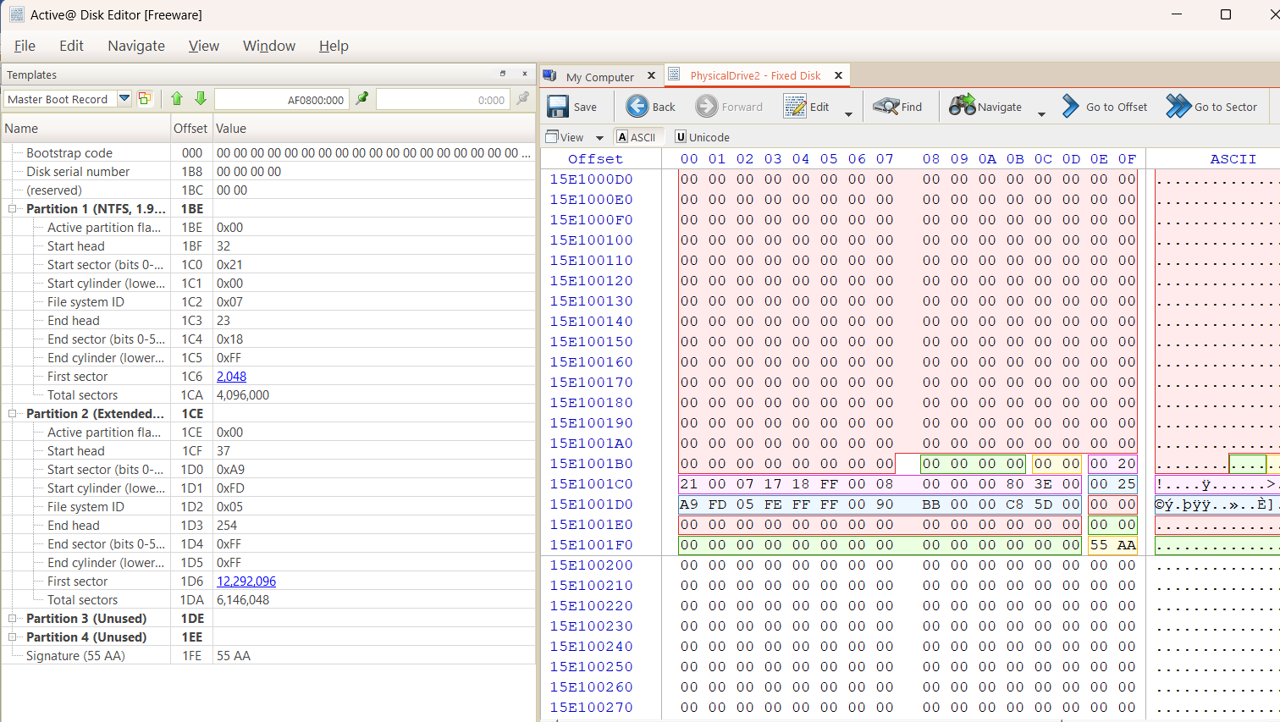

# Third Requirement (FTK Imager)

## Open Image

1. Lunch FTK Imager
2. Add evidence by go to file -> add evidence.  
   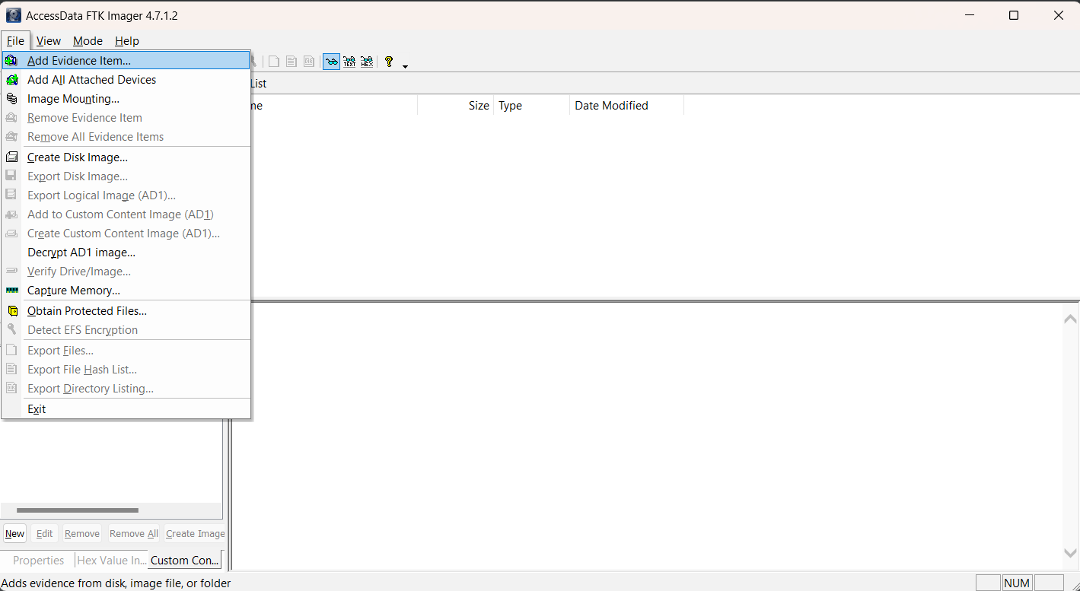
3. Select image file as shown then click “next”.  
   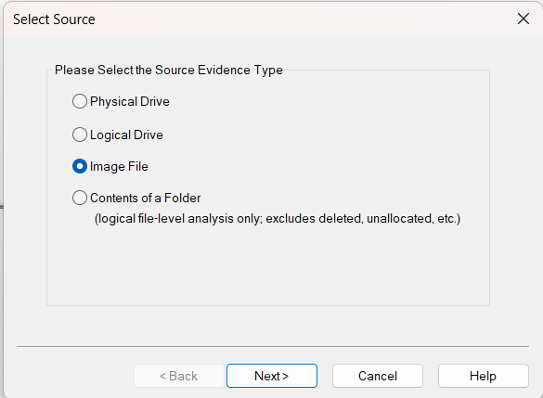
4. Now, click on browse, select flash image and click finish.  
   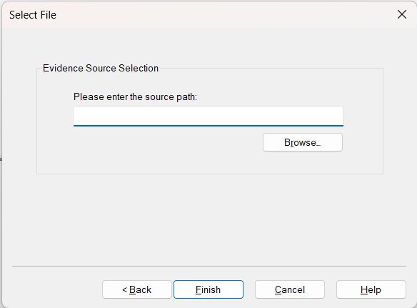

## Search for a specific file

1. In evidence tree. Open device -> partition 1 -> salah -> root.  
   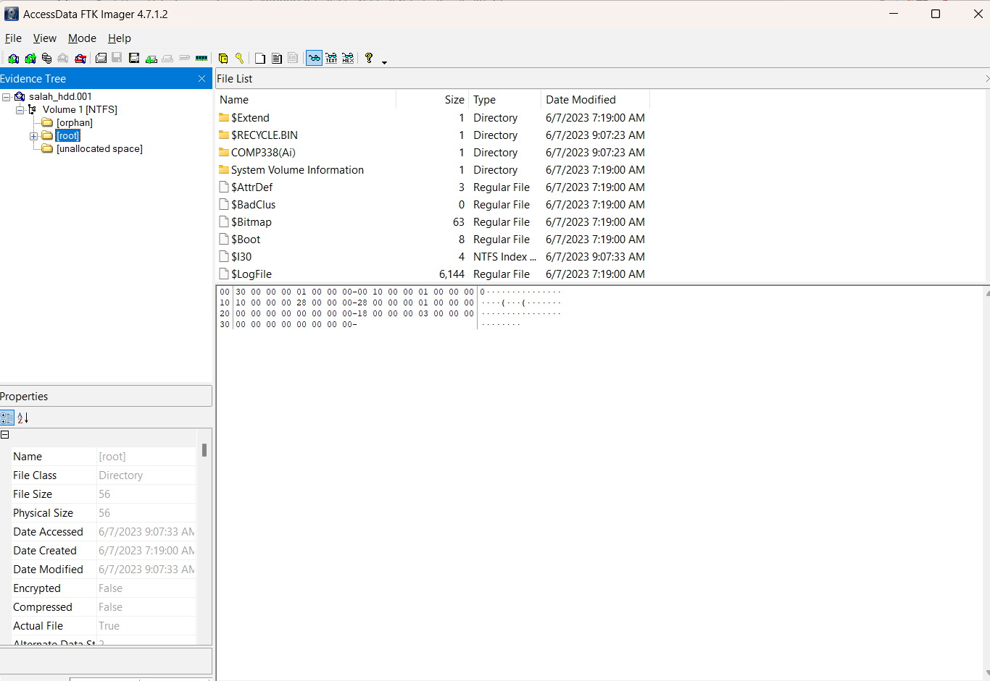

1. Choose MFT file and click on bottom screen

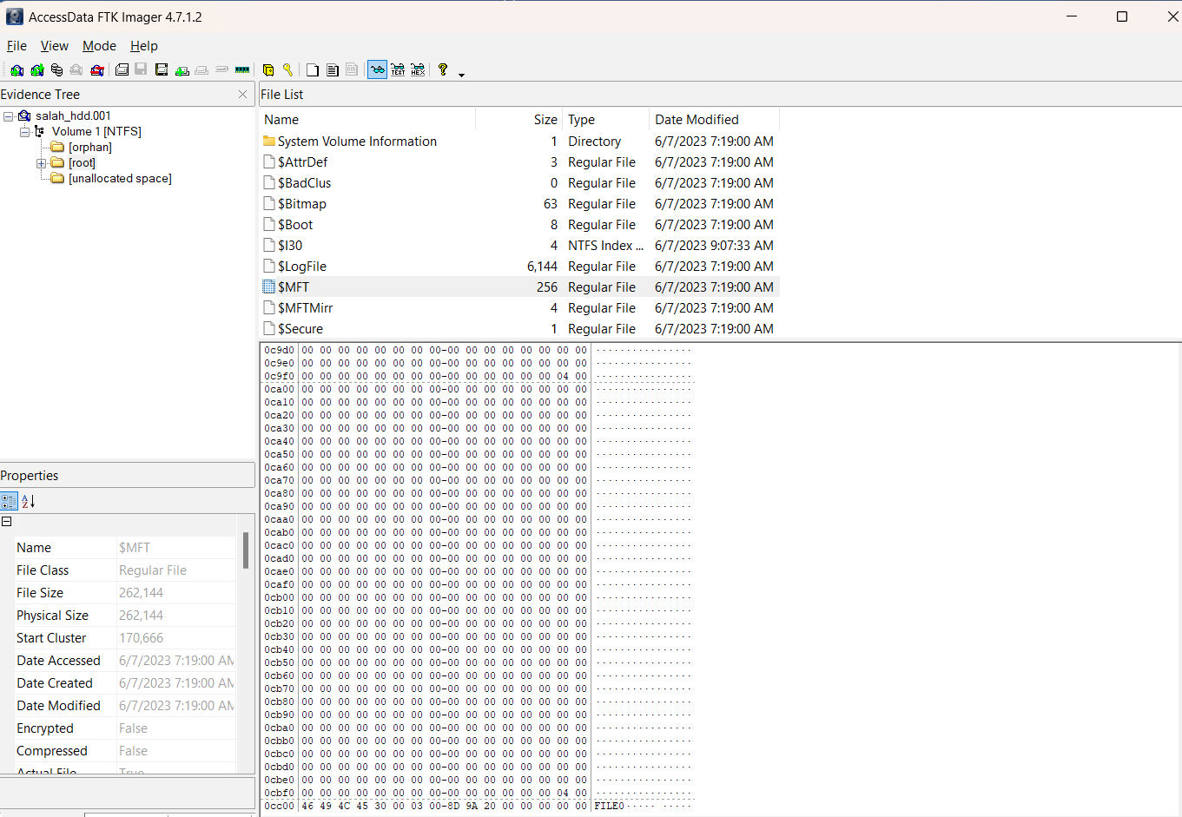

1. click CTRL + F and write what you want to search

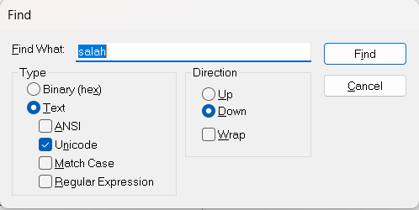

1. Done, I have file named salah tawafsha.pdf

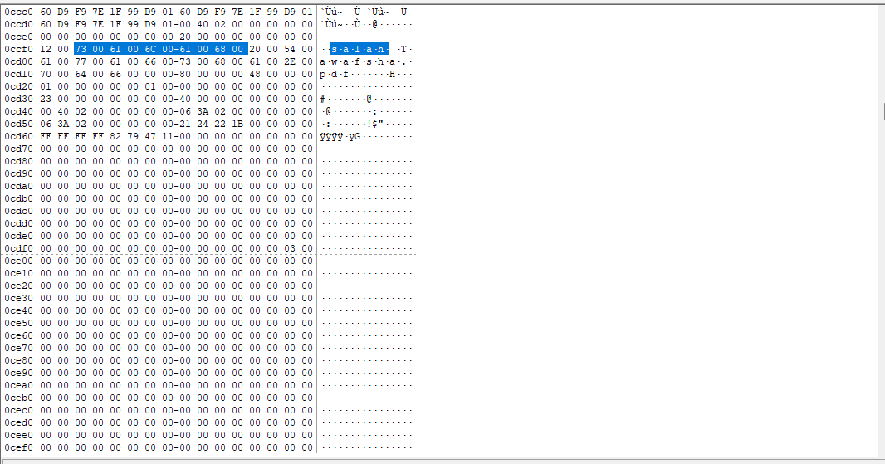

## Define the size of file in KB

* after 80 00 00 00 we will select 64 bytes (Can show info bellow to know how much length)
* look at next byte (21), this define that 1 byte next for # clusters, 2 is 2 bytes for first cluster
* Look at next of next byte its 24, this is the number of clusters to store file in Hex.
* 24 = 36 cluster -> 36 * 4096 = 147,456 byte -> 144 KB
* In second pic, we can find actual size of file that after 48 bytes of 80 00 00 00
* 06 3A 02 00 so its 02 3A 06 => 145,926 bytes = 142 KB  
  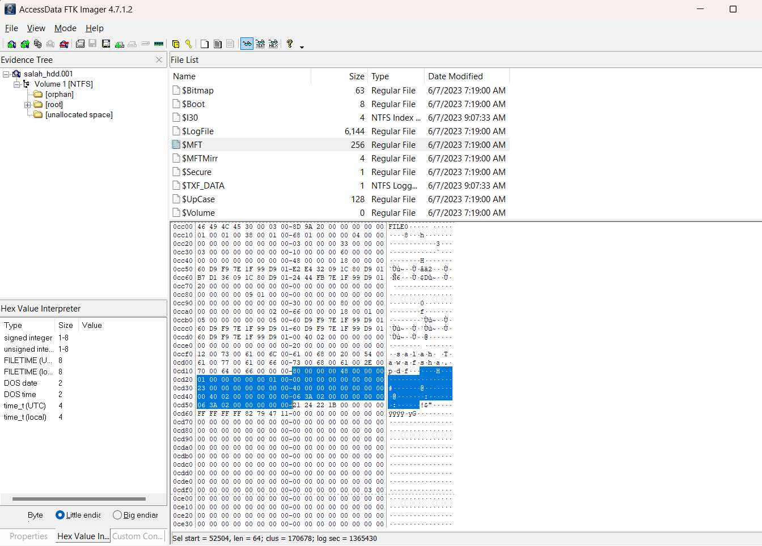   
    
  

0

0

## Define the first sector of the selected file

* look at next two bytes, it’s 22 1B in little Indian, so its 1B 22 -> 6,946 is the start cluster  
   6,946 * 4069 = 28,450,816 is start sector  
  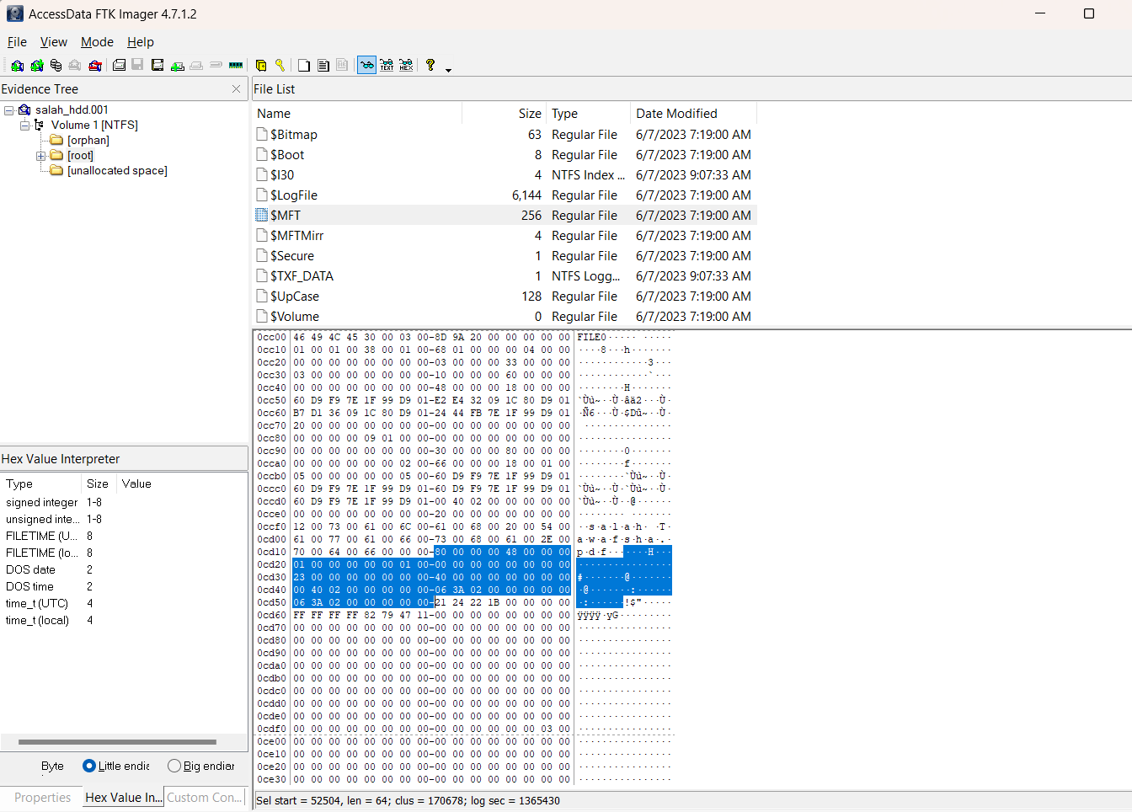

## Define if the file was sequence stored or not

Sequence since its not deleted so no override

## define different partitions of file NOT in sequence.

Select deleted file and with make move to folder

## Select the content of the file (fragmented file).

Use extension to make that

## Store and recover both files

* Go to start of file (Cluster 6,946)  
  
* right click on start and select “set Selection length”  
  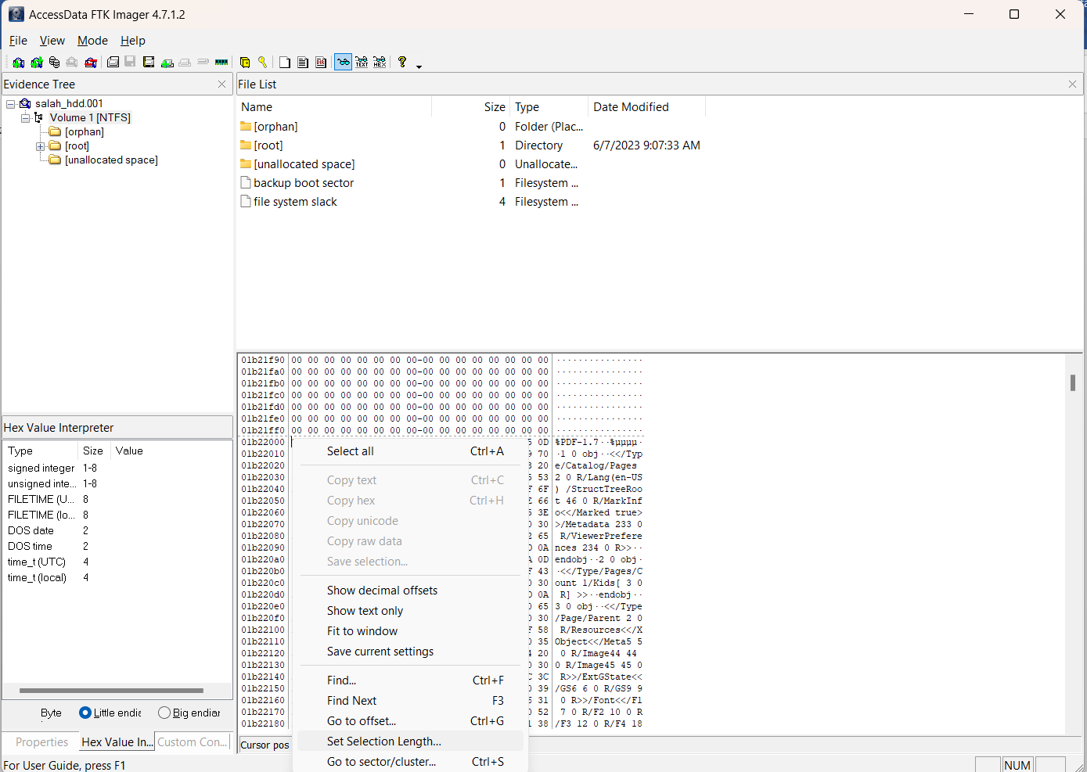
* Enter size of file that calculated above  
  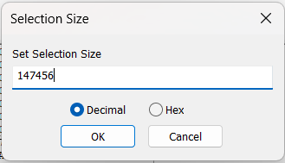
* Select “save selection”  
  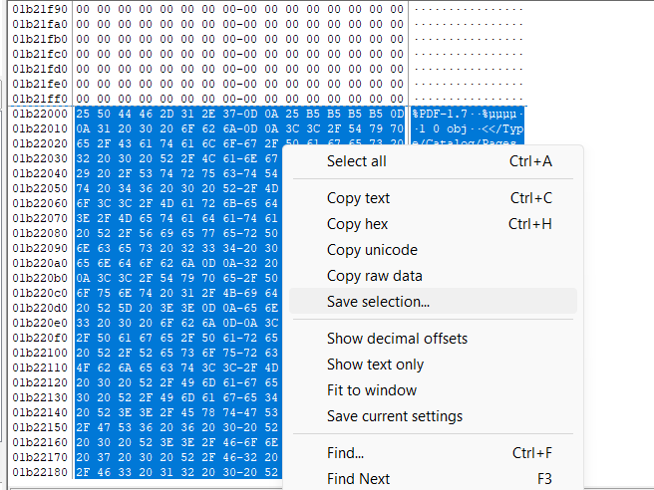
* Select path and name and click save  
  